Startforth War Memorial

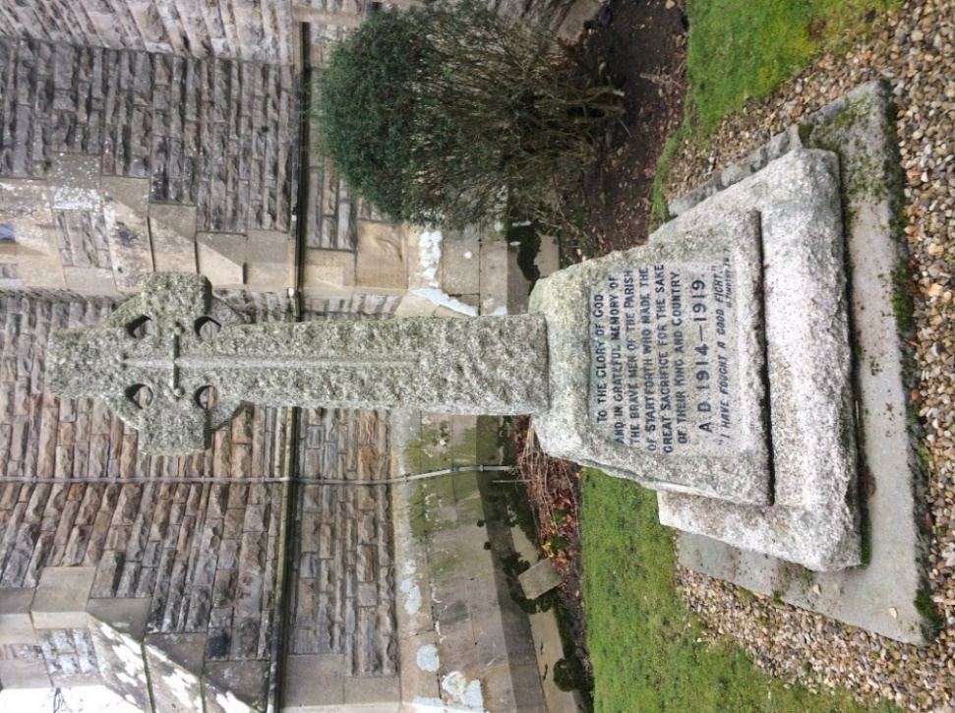

- Introduction

Startforth War Memorial (Startforth WM) will be described below, the process involved in erecting it will be detailed as will later modifications and repairs. Photographs of the Memorial are presented in Appendix 1; Appendix 2 has a picture of the Balance Sheet and Subscribers who raised funds for the Memorial; the men commemorated from World War 1 (WW1) and World War 2 (WW2) are listed in Appendix 3.

The village of Startforth is in South West County Durham, England, on the opposite bank of the River Tees from the market town of Barnard Castle. The ecclesiastical parish of Startforth also includes settlements at Boldron and Egglestone Abbey, with a combined population of 661 in 1911.

- Location, shape and form

Startforth WM is in the churchyard of Startforth Holy Trinity Church. The War Memorial is situated in a prominent position on the south west corner of the Church, beside the main path between the lych-gate and the church door (see Appendix 1). Most people who visit the Church walk directly past the Memorial.

Startforth WM is a Celtic cross made from grey Cornish granite with a sword pointing downwards on its face, approximately two metres in height (Appendix 1 has exact measurements). A dedication inscribed on the south side of the cross base states

‘TO THE GLORY OF GOD AND IN GRATEFUL MEMORY OF THE BRAVE MEN OF THE PARISH OF STARTFORTH WHO MADE THE GREAT SACRIFICE FOR THE SAKE OF THEIR KING AND COUNTRY
AD 1914 – 1919.’

There is also a short quotation from the Authorised King James version of the Bible from 2 Timothy 4:8

‘I HAVE FOUGHT A GOOD FIGHT’

indicating the views of the Committee who commissioned the cross. A bronze plaque detailing the names of the fallen of WW1 is on the west side of the cross base and another bronze plaque is on the east side for those men who died in WW2.

- Those listed on the memorial

There are twelve men commemorated from WW1 and four men commemorated from WW2. The details recorded about the men are their names in alphabetical order without rank or regiment, inscribed in block capitals on bronze plaques, indicating that the community wanted an egalitarian memorial.

The WW1 plaque dates the war as being from 1914 to 1919, when the Treaty of Versailles was signed and not the Armistice of November 1918.
The WW2 plaque also states that Startforth WM was renovated in 1995. Names and brief details of the men are outlined in Appendix 3.

- What is commemorated

Startforth WM commemorates only those who died in both World Wars. Those who served in WW1 from the locality had their names entered in a Roll of Honour (see Appendix 4). All those who served in the three parishes and the widows or parents of those who died were invited to a Peace Celebration in August 1919, where 96 inscribed bronze medals were distributed .

- History of the memorial

It was first reported in March 1919 that ‘A memorial worthy of those who from the parish of Startforth have died for their country, will, it is hoped, be eventually placed in the church or churchyard’. In April 1919, Startforth Parish Council Minute Book records that the Parish Meetings of Boldron and Egglestone Abbey be asked to join with Startforth to raise a War Memorial.

The first mention in Boldron Parish Meeting’s Minute Book is on 25th March 1919 when it was recorded that the memorial was being delayed until ‘after peace was signed and the Boys of the District Demobilised’. A Special Meeting was called in Boldron on 6th May 1919 when it was decided that Boldron would join with Startforth and Egglestone Abbey to raise a war memorial.

The following article appeared in the Local Notes section on page 3 of the Teesdale Mercury of 28 May 1919 indicating that there was already some tension about where to place the memorial and what form it should take.

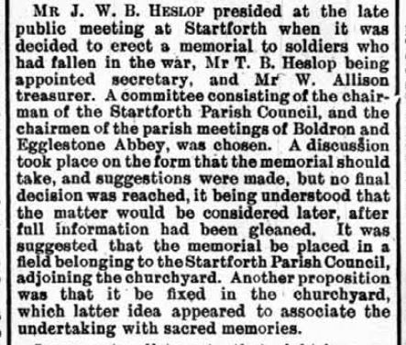

One public meeting in which the wishes of participants overcame plans put forward by the committee was fully reported in the Teesdale Mercury of 10 March 1920.

The proposal from the Committee was that the memorial should take the form of a ‘stone seat to be placed in the west corner of the parish field’ with ‘the names of the fallen heroes carved on the back, overhead’. The suggestion to have a memorial monument in the churchyard was not seconded in Committee, so had not been brought to the public meeting. However, the public meeting strongly favoured the second option and its proposer in Committee, Mr Bailey, who was father of one of the dead to be commemorated and Headmaster of the village school, said he would overcome his views to gain consensus. The Committee Secretary (Major T B Heslop), then spoke up to say that the seat had been his idea and he thought any memorial in the churchyard would have to be behind the church.

The Vicar (Mr Manby) then proposed that a grassed area at the south west of the church be used. Many people attending were non-conformists and Mr Peverley spoke up for them, saying that they would like a memorial in the churchyard ‘because it was a sacred place’. This comment demonstrates that all denominations in the parishes desired a memorial in a place of respect.

Mr Storey (another father of a soldier to be commemorated) asked that the amended scheme be accepted without further argument, a plea that was apparently heeded. The Vicar stated that he would pay the Diocesan faculty fee himself and that he hoped the memorial would be in the form of a cross.

The design of the Startforth War Memorial had been decided by early August 1920, reported in the Teesdale Mercury of 4th August 1920.

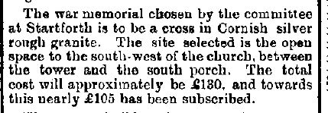

A faculty was granted ‘for the erection in the churchyard of a cross of Cornish granite as a memorial to the men killed in the Great War’ on 14 August 1920.

The amount raised for the project was just over £130 which was all spent by the Committee (see Appendix 2). Startforth WM was built by Appleby stonemasons of Barnard Castle.

The service to dedicate the memorial in February 1921 was attended by many people who were said to be ‘deeply moved’. The address was given by Captain JJ Bell-Irving of nearby Rokeby Hall, who then unveiled the memorial. The names of the men who were commemorated were then read out, followed by the playing of the Last Post and the singing of the National Anthem. This newspaper report demonstrates how much the memorial was valued in the locality.

There appears to be no further record until the 1990’s when there was a move to spend money collected after WW2 for a Welcome Home Fund and Village Hall. In November 1994, the Teesdale Mercury carried an article on its front page asking for ideas on spending the money. A letter written in reaction to this plea from an ex-serviceman objected to this money being used towards renovating the War Memorial. However, despite this protest it was decided to repair the War Memorial and the following report was published in the Teesdale Mercury of 15 November 1995. ‘The village war memorial has been cleaned and refurbished at a cost of £784 by Messrs Bainbridge Brothers of Darlington. Names have been engraved on bronze plaques to replace those on which some letters were missing and others had corroded.’ An editorial on page 4 of the same edition stated that this was a good way to spend the money. The lasting value placed on this Memorial by the local community is indicated by its continued neat appearance.

- Information held about the memorial online or in libraries or archives

The main source of information about Startforth WM is online from the Teesdale Mercury Archive website. Durham County Record Office holds a copy of the list of subscribers and balance sheet, the Faculty documentation from Ripon Diocese and the Roll of Honour for the parishes. The Bowes Museum is in the process of compiling a Roll of Honour of those who served in WW1; some of those commemorated on Startforth WM have been researched.

There is no record of this war memorial on the Imperial War Museum website, although there are records of individuals commemorated on individual gravestones in the churchyard. It is a similar situation with the North-East War Memorials Project.

- Conclusion

The War Memorial commemorating the men who died in both World Wars of Startforth, Boldron and Egglestone Abbey has not been officially recorded in some of the national and regional projects which aim to record all such monuments. There is ample information about Startforth WM in the surviving records to gain a good understanding of the process involved in its commissioning, dedication and of the men named upon it; dissemination of this report should remedy this situation.

Appendix 1
Photographs of Startforth War Memorial

The Memorial situated at the south-west corner of Startforth Holy Trinity Church

Measurements
Cross height: 153cm.
Cross Depth: 24cm to 17cm.
Combined Base Height: 82cm.
Base Width: 112cm; depth: 79cm.
Plaques with names inscribed: width: 45cm; height: 30cm.

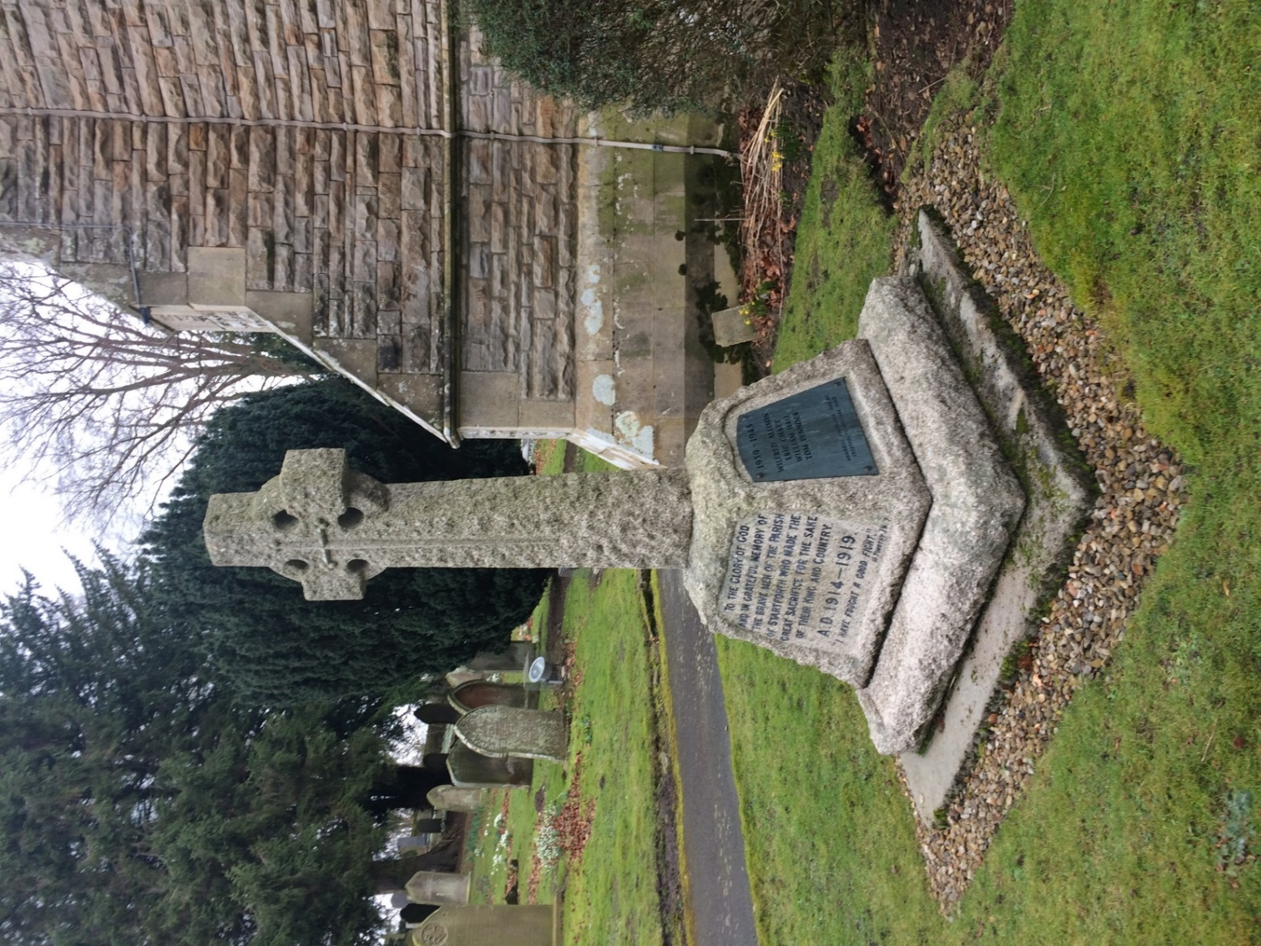
Startforth Holy Trinity Church, showing position of War Memorial on South West Corner of the Church

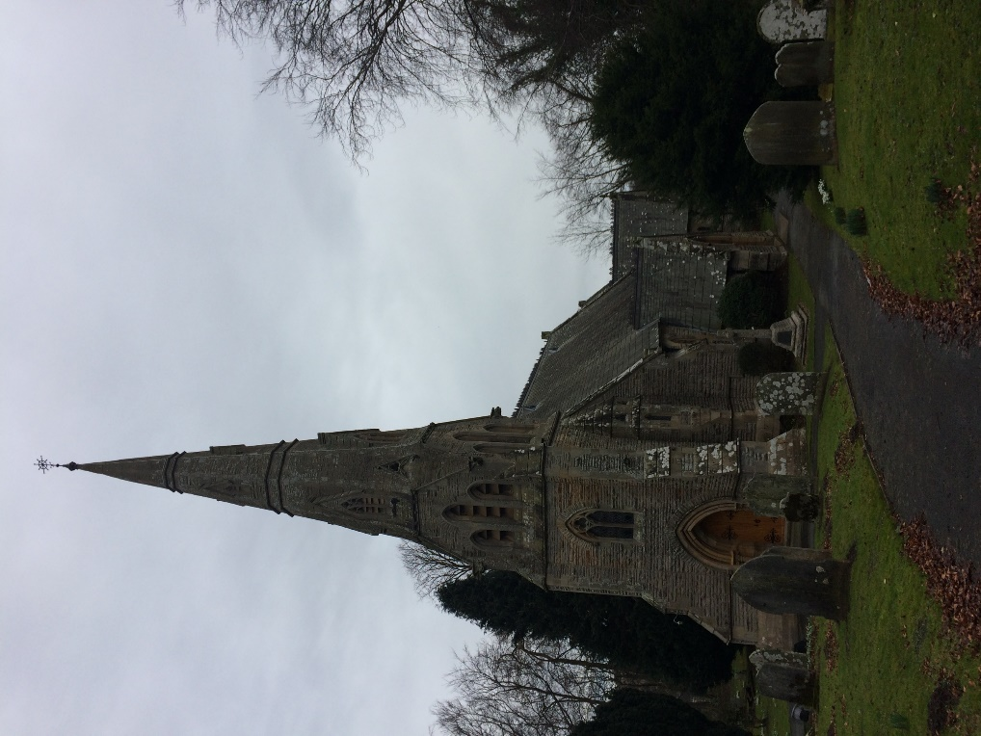

Dedication on Startforth War Memorial (north face of Memorial)

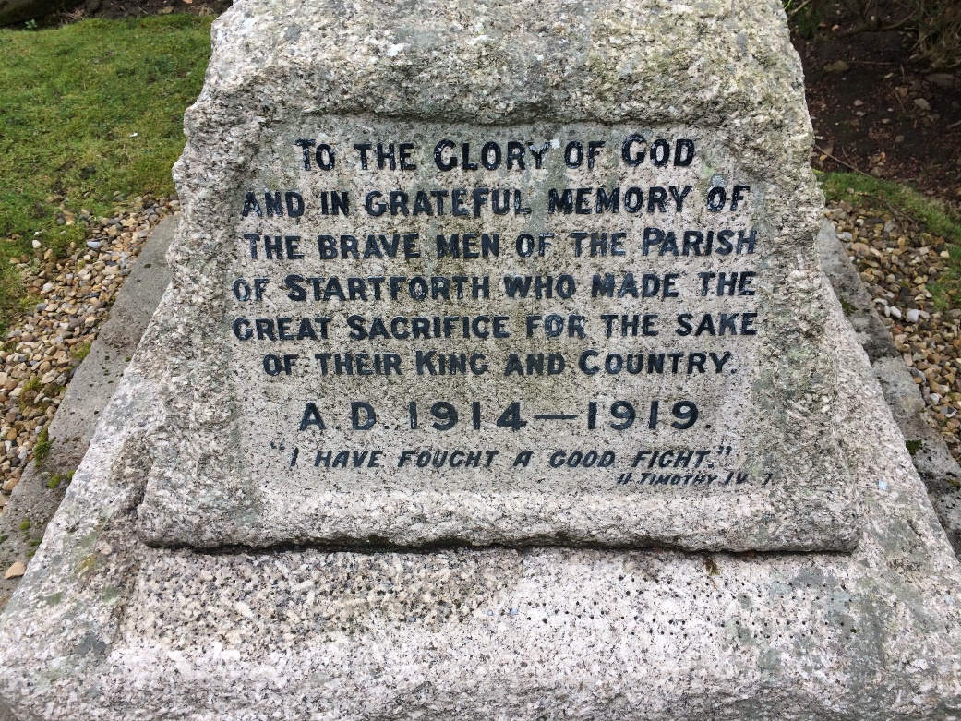
World War 1 Men Commemorated (west face of Memorial)

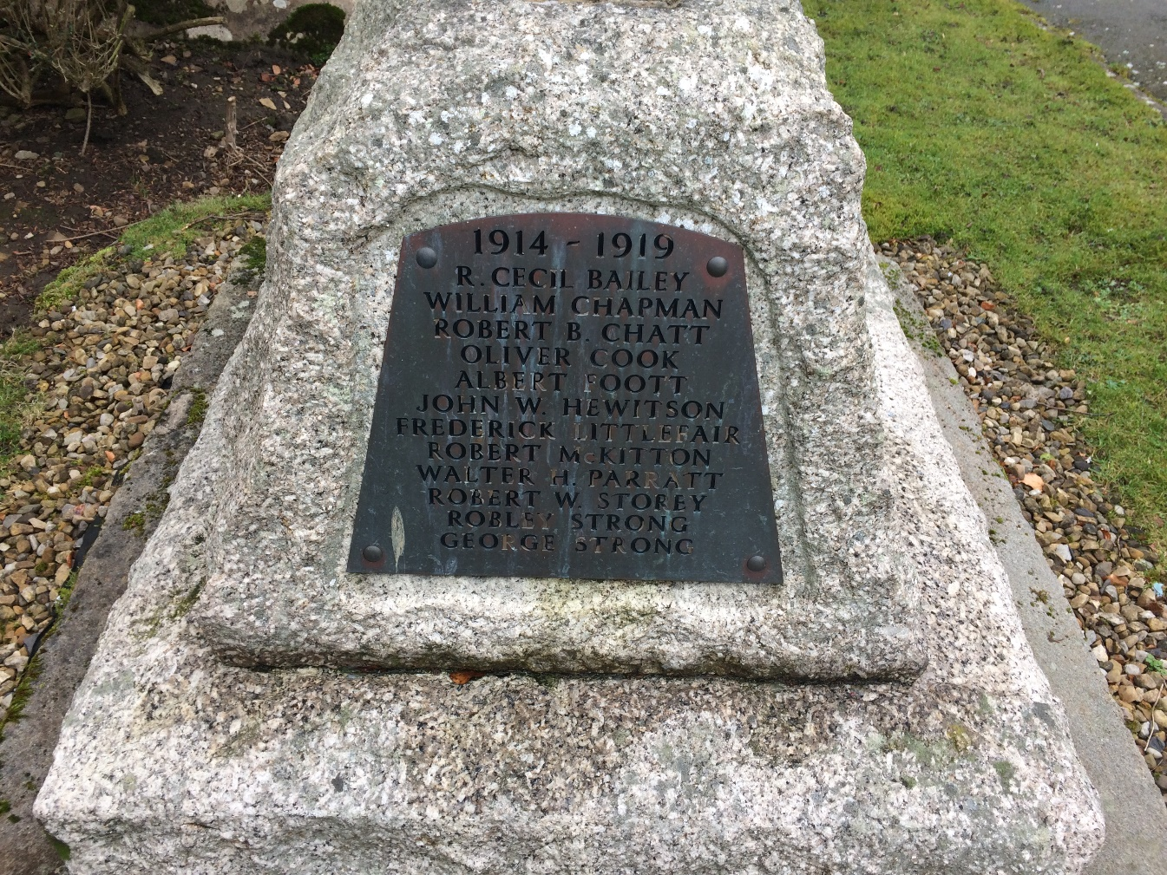

World War 2 Men Commemorated (east face of Memorial)

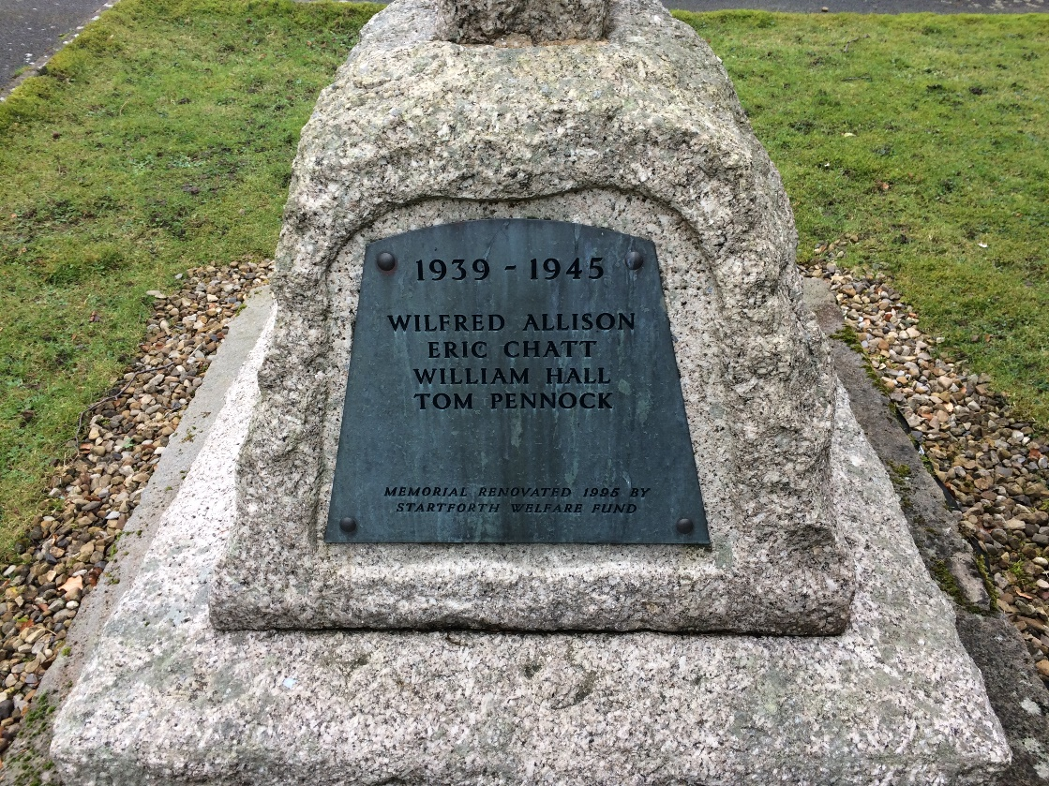
Appendix 2
Balance sheet for, and list of subscribers to, the Startforth War Memorial Fund, 20 April 1921
Durham County Record Office Ref EP/Star 14/16

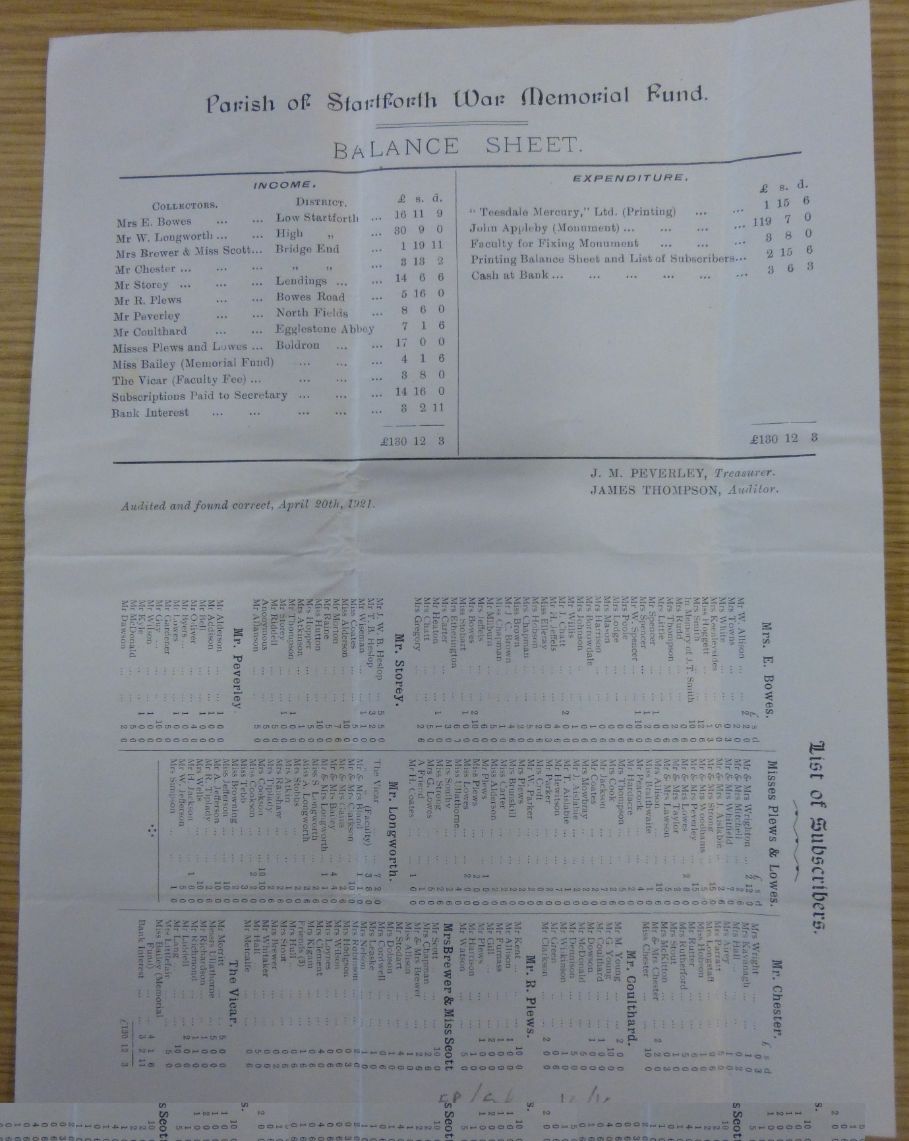

Appendix 3
World War 1 Men Commemorated on Startforth War Memorial

Robert Cecil Bailey (Private)

PS/8784, 28th Battalion, Royal Fusiliers, who died on 02 February 1916, age 22.

Remembered with Honour in Startforth (Holy Trinity) Churchyard.

Teesdale Mercury Report 9 February 1916

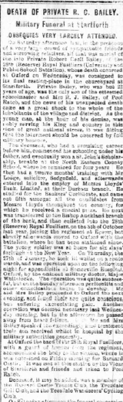

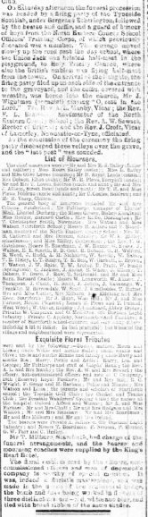
William Chapman (Lance Corporal)

251047, 1st/6th Battalion, Durham Light Infantry, who died on 09 July 1917, age 31.

Remembered with Honour in Wancourt British Cemetery.

Teesdale Mercury 10 July 1918

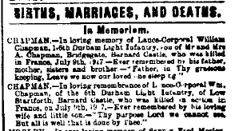

Robert Bulmer Chatt (Sapper)

WR/259810, 32nd Light Railway Operating Company, Royal Engineers, who died on
11 November 1918, age 25.

Remembered with Honour in Faubourg D'amiens Cemetery, Arras.

Teesdale Mercury 27 November 1918

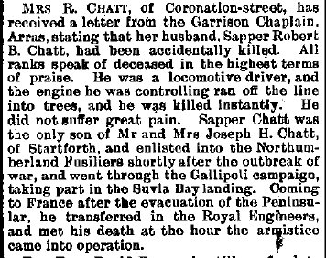

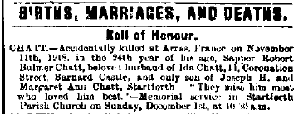

Oliver Cook (Private)

17/662, 17th Battalion, Northumberland Fusiliers who died on 30 October 1917,
age 22.

Remembered with Honour in St. Julien Dressing Station Cemetery.

Teesdale Mercury 14 February 1917

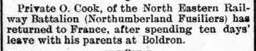

Teesdale Mercury 7 November 1917

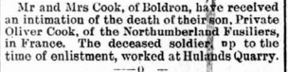

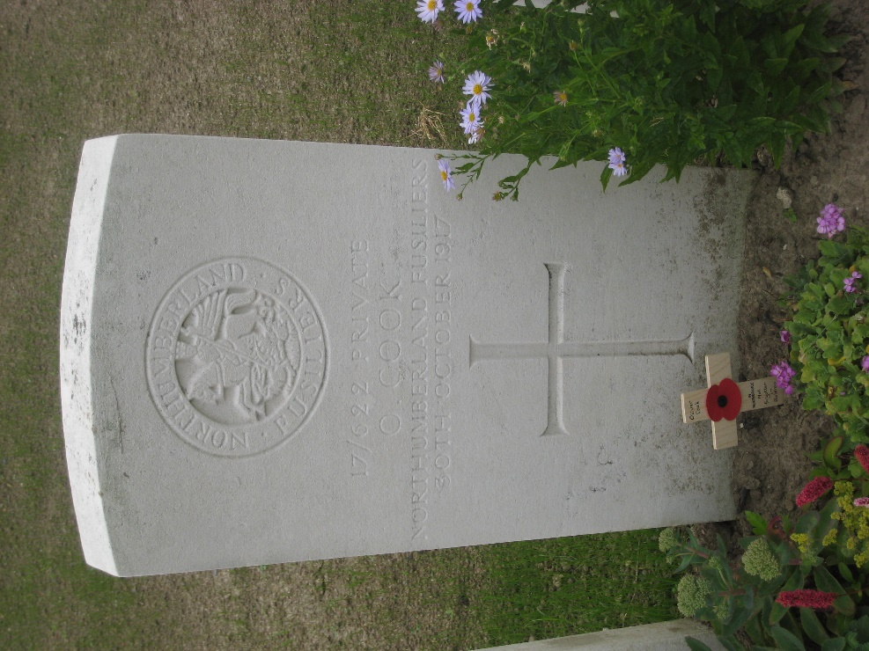
Albert Foott (Private)

36918, 7th Battalion, East Yorkshire Regiment who died on 02 April 1918, age 38.

Remembered with Honour in Blighty Valley Cemetery, Authuille Wood.

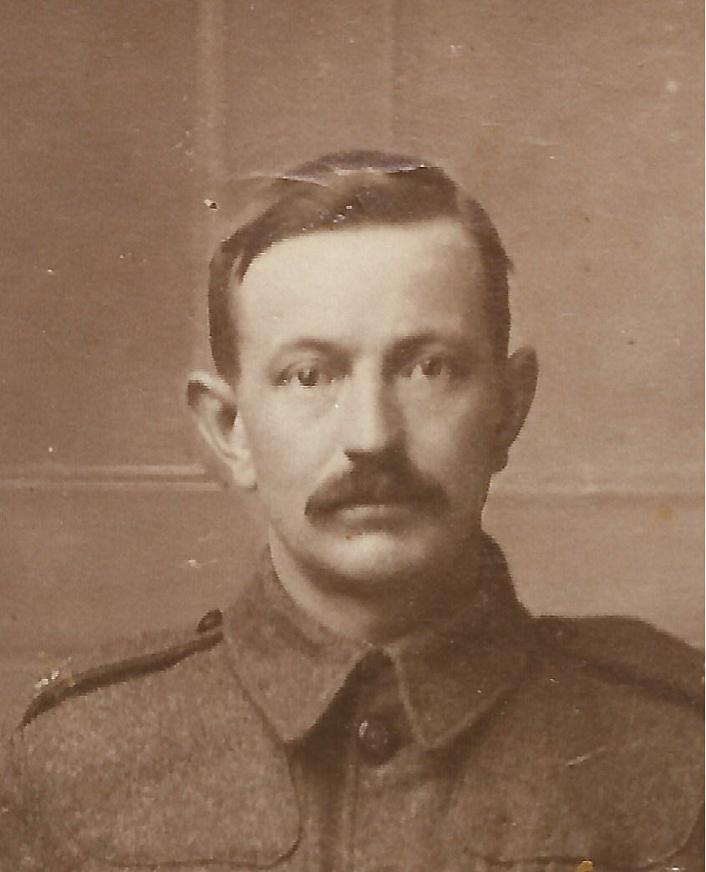
Picture Source: Ancestry Family Tree - foott1, added by Ann Foott

Teesdale Mercury 8 May 1918

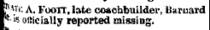

Teesdale Mercury 20 November 1918

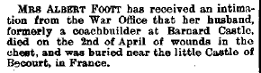

John William Hewitson (Private)

G/79999, 4th Bn., Royal Fusiliers who died on 18 September 1918, age 22.

Remembered with Honour on Vis-En-Artois Memorial.

Teesdale Mercury 16 October 1918

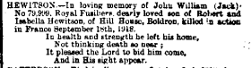

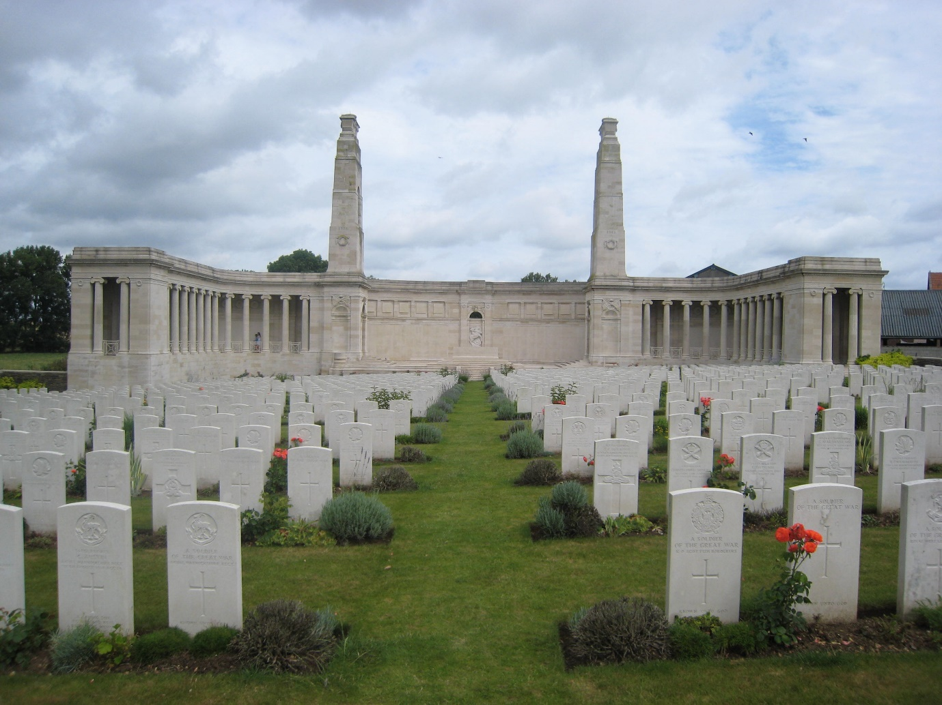

Frederick Littlefair (Private)

30585, 9th Battalion, Yorkshire Regiment who died on 20 September 1917, age 41.

Remembered with Honour on Tyne Cot Memorial.

Teesdale Mercury 17 October 1917

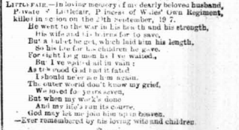

Robert McKitton (Private)

5298, 2nd Battalion, Yorkshire Regiment who died on 12 March 1915, age 36.

Remembered with Honour on Le Touret Memorial.

Teesdale Mercury 13 March 1918

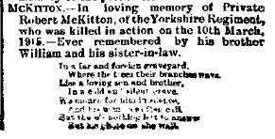

Walter Herbert Parratt (Private)

18773, 13th Battalion, Gloucestershire Regiment who died on 30 March 1918,
age 43.

Remembered with Honour on Pozieres Memorial.

Teesdale Mercury 8 May 1918

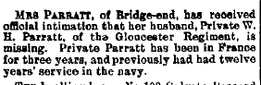

Robert William Storey (Second Lieutenant)

1st Battalion, Durham Light Infantry attached to Machine Gun Corps, who died on 09 March 1918, age 21.

Corporal in 18th Hussars before receiving Commission
.
Remembered with Honour in The Huts Cemetery.

Teesdale Mercury 10 October 1917

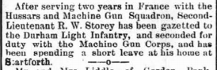

Teesdale Mercury 20 March 1918

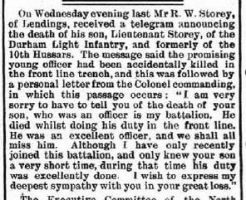

Robley Strong (Gunner)

63159, "D" Battery 18th Brigade, Royal Field Artillery who died on 30 September 1917, age 23.

Remembered with Honour at Outtersteene Communal Cemetery Extension, Bailleul.

Teesdale Mercury 2 October 1918

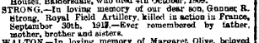

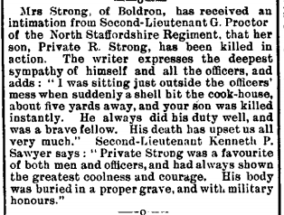

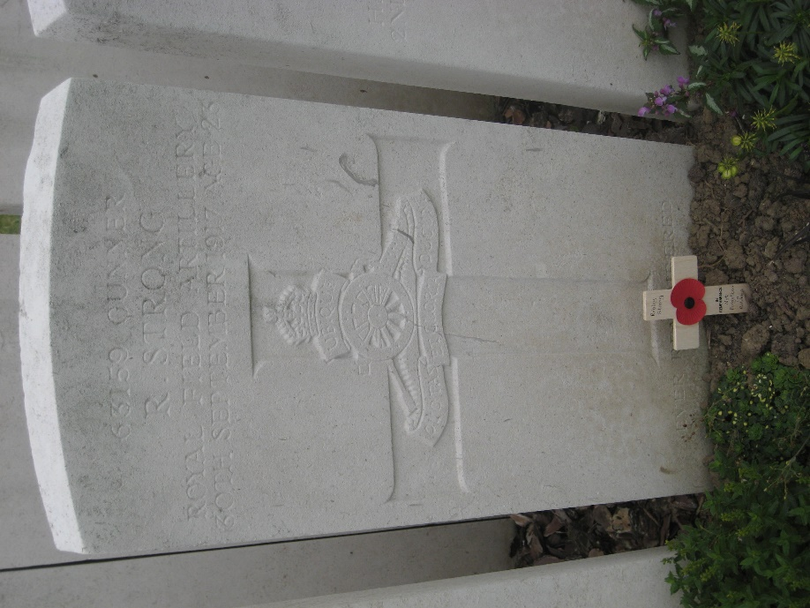

George Strong (Private)

40169, 2nd/6th Battalion, North Staffordshire Regiment who died on 15 April 1918, age 19.

Remembered with Honour on Ploegsteert Memorial

Teesdale Mercury 22 May 1918

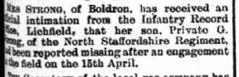

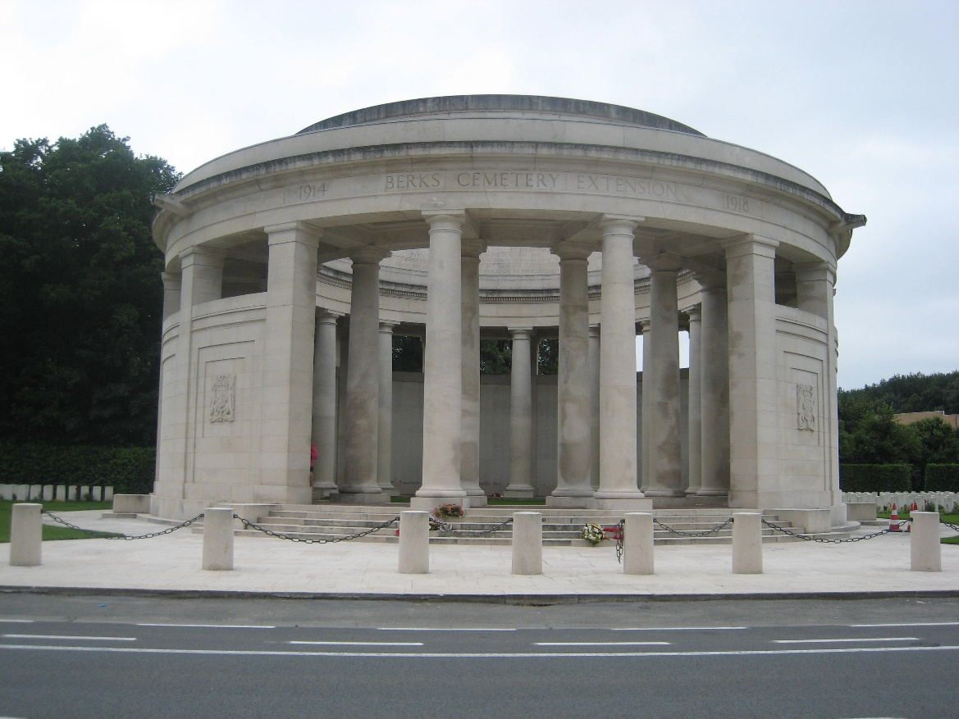

World War 2 Men Commemorated on Startforth War Memorial

Thomas Wilfred Allison (Private)

4458107, 10th Battalion, Durham Light Infantry who died on 15 June 1941, age 22.

Remembered with Honour at Reykjavik (Fossvogur) Cemetery.

Teesdale Mercury 25 June 1941

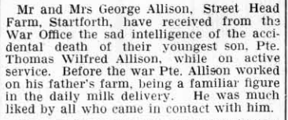

Eric Chatt (Sergeant)

518522, Royal Air Force who died on 16 February 1942, age 27.

Remembered with Honour on Singapore Memorial.

Teesdale Mercury 25 March 1942

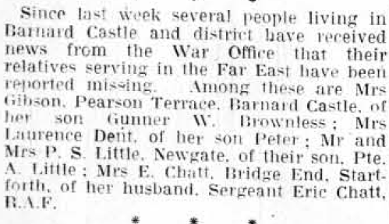

James William Hall (Private)

4459057, 10th Battalion, Durham Light Infantry who died on 20 February 1945,
age 27.

Remembered with Honour at Prague War Cemetery.

Teesdale Mercury 1 August 1945

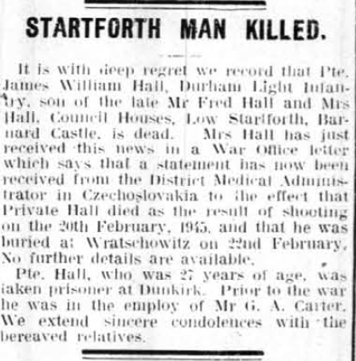

Thomas Pennock (Sergeant)

1482988, 126 Squadron, Royal Air Force Volunteer Reserve who died on 07 April 1943 age 25.

Remembered with Honour on the Malta Memorial.

Teesdale Mercury 21 April 1943

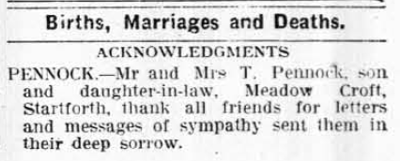

Appendix 4
Startforth Roll of Honour
Durham County Record Office Ref EP/Star 14/15

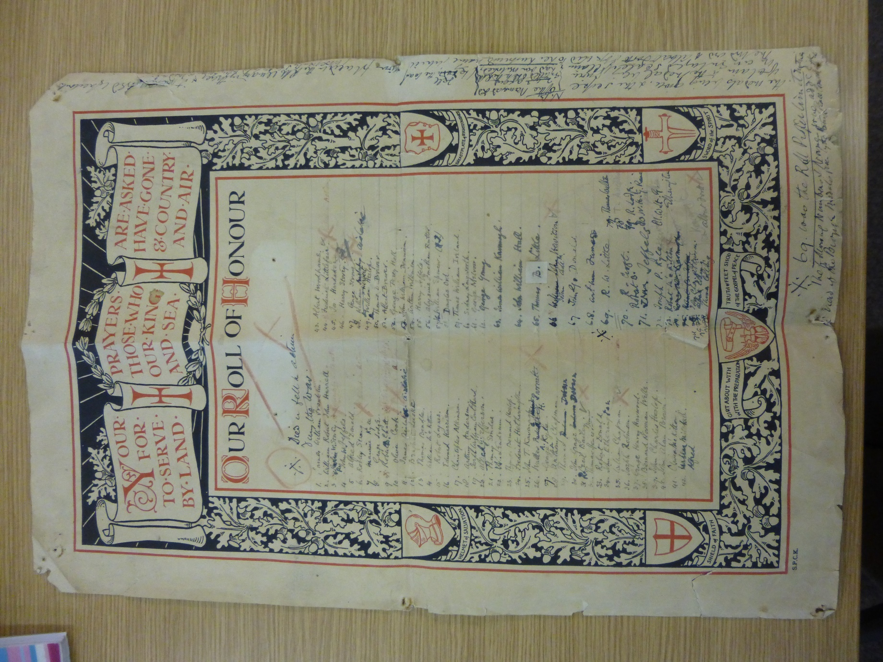

Obtained by combining population totals from the Vision of Britain Through Time website at http://www.visionofbritain.org.uk/, accessed 11/3/2017.
From the New Testament of the Holy Bible, Edinburgh, 1958, p.206.
The Roll of Honour is held by Durham County Record Office Ref: EP/Star 14/15.
This was reported on page 3 of the Teesdale Mercury of 13 August 1919, http://teesdalemercuryarchive.org/extra/pdfviewer/pdfviewer.php?date=1919-08-13&startpage=1, accessed 10/3/2017.
This was reported on page 3 of the Teesdale Mercury of 5 March 1919, http://teesdalemercuryarchive.org/extra/pdfviewer/pdfviewer.php?date=1919-03-05&startpage=1, accessed 10/3/2017.
Startforth Parish Council Minute Book is held at Durham County Record Office, Ref: RD/St 246-247.
The edition can be found at http://www.teesdalemercuryarchive.org.uk/extra/pdfviewer/pdfviewer.php?date=1919-05-28&startpage=3, accessed 11/3/2017.
A detailed report of the meeting is accessible at http://www.teesdalemercuryarchive.org.uk/extra/pdfviewer/pdfviewer.php?date=1920-03-10&startpage=8, accessed 11/3/2017.
This report is accessible at http://teesdalemercuryarchive.org/extra/pdfviewer/pdfviewer.php?date=1920-08-04&startpage=1, accessed 11/3/2017.
This is archived at Durham County Record Office, Ref: EP/Star 4/44.
This report is accessible at http://teesdalemercuryarchive.org/extra/pdfviewer/pdfviewer.php?date=1921-02-16&startpage=1, accessed 11/3/2017.
This report is accessible at http://teesdalemercuryarchive.org/extra/pdfviewer/pdfviewer.php?date=1994-11-23&startpage=1, accessed 11/3/2017.
This report is accessible at http://teesdalemercuryarchive.org/extra/pdfviewer/pdfviewer.php?date=1995-01-18&startpage=1, accessed 10/3/2017.
This report is accessible at http://teesdalemercuryarchive.org/extra/pdfviewer/pdfviewer.php?date=1995-11-15&startpage=1, accessed 10/3/2017.
This is searchable at http://www.teesdalemercuryarchive.org.uk/, accessed 10/3/2017.
The collection is searchable at http://www.durhamrecordoffice.org.uk/article/8338/Home, accessed 10/3/2017.
This is searchable at The Bowes Museum First World War Commemoration Project, http://www.thebowesmuseumww1.org.uk/, accessed 10/3/2017.
This is searchable at http://www.iwm.org.uk/memorials/search, accessed 11/3/2017.
This is searchable at http://www.newmp.org.uk/index.php, accessed 11/3/2017.

